
New College Society

The Charterhouse

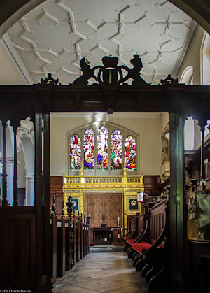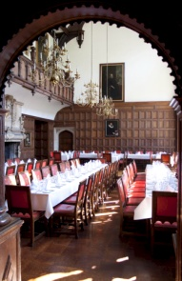

Booking Form

Name: ____________________________________________________________

Name of guest/s____________________________________________________

Email: ____________________________ Telephone: ______________________

I enclose a cheque for: £________ (please make cheques payable to
‘New College’)

OR

Please charge £______ to my debit/credit card (not American Express)

Number___________________________________________________________

Name (as it appears on the card)_______________________________________

3 digit security code (reverse of card) _____ Start date _____ End date _____

Please return this form to: Jonathan Rubery, Communications & Events Manager, Development Office, New College, Oxford OX1 3BN by Friday 6 June 2014. Telephone: 01865 279337 or email: jonathan.rubery@new.ox.ac.uk

